**Batch: IT A-4 Experiment Number: 01**

**Roll Number: 16010422211 Name: Chetana Kulkarni**

**Aim of the Experiment:** Study of various networking commands**.**

Program/ Steps:

1. Ping
2. Ipconfig
3. Tracert
4. Arp
5. Netstat

**Output/Result:**

1. **Ping**

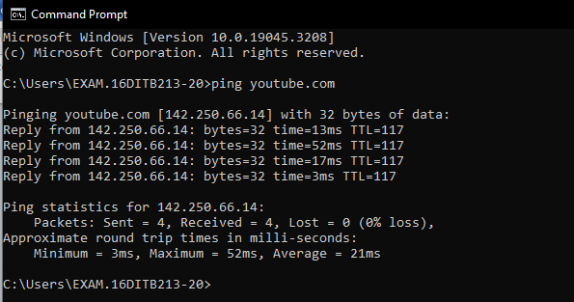

1. **Ipconfig**

**/all**

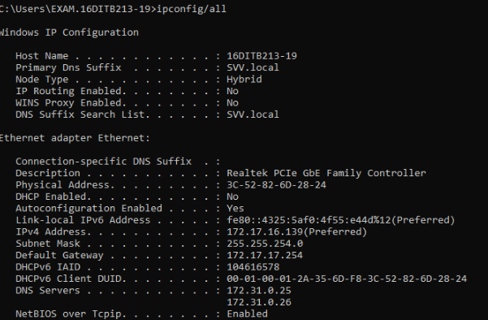

**/renew [Adapter]**

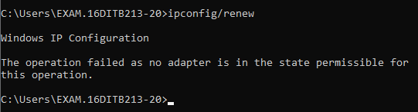

**/release [Adapter]**

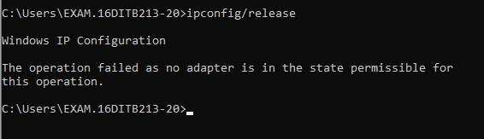

**/flushdns**

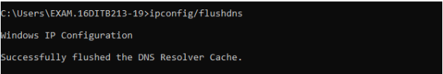

1. **Tracert**

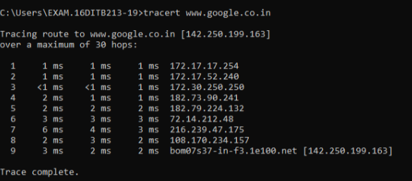

1. **Arp**

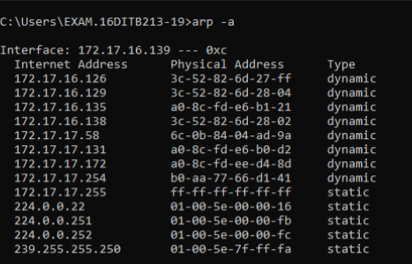

1. **Netstat**

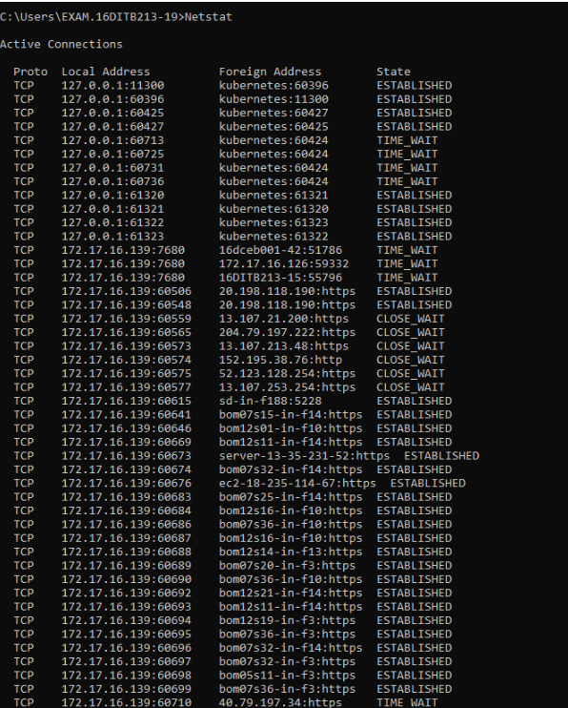

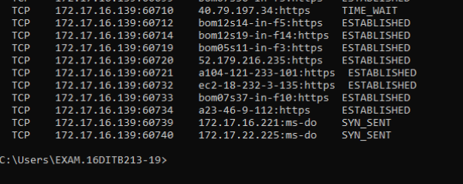

**Post Lab Question-Answers:**

**Questions**

**1. ICMP is used in _________**

a) Ping

b) Traceroute

c) Ifconfig

d) Both Ping & Traceroute

**Ans : (A) Ping**

**2. __________ command is used to manipulate TCP/IP routing table.**

a) route

b) Ipconfig

c) Ifconfig

d) Traceroute

**Ans : (B) Ipconfig**

**3. Select the false statement from the following.**

a) Nslookup is used to query a DNS server for DNS data

b) Ping is used to check connectivity

c) Pathping combines the functionality of ping with that of route

d) Ifconfig can configure TCP/IP network interface parameters

**Ans : (C) Pathping combines the functionality of ping with that of route**

**Outcomes:**

*Understand the data communication system, network topologies and network devices.*

**Conclusion (based on the Results and outcomes achieved):**

1. **Ping**: A utility used to test the reachability of a host(computer/device) on an IP network.
2. **Ipconfig:** Displays the network configuration information for all network interfaces on the local computer.
3. **Tracert**: Traces routes taken by packets from your computer to a specified destination**.**
4. **Arp:** Allows you to view and manipulate the local ARP cache.
5. **Netstat:** Displays network statistics and the current TCP/IP network connections.

**References:**

Books/ Journals/ Websites:

• Behrouz A Forouzan, Data Communication and Networking, Tata Mc Graw hill,

India, 4th Edition

• A. S. Tanenbaum, ”Computer Networks”, 4th edition, Prentice Hall

• Behrouz A Forouzan, Data Communication and Networking, Tata Mc Graw hill,

India, 4th Edition

• A. S. Tanenbaum, ”Computer Networks”, 4th edition, Prentice Hall